Course: CSN 405 – Network Programming
LAB 6 – Linux Command Line and Log File Processing

Student name | Phan Ngọc Hạnh Nhi
Student ID | 2131209002

Create a sample file: access.log
192.168.1.1 - - [12/Mar/2026:10:00:00] "GET /index.html HTTP/1.1"
192.168.1.2 - - [12/Mar/2026:10:01:00] "POST /login HTTP/1.1"
192.168.1.3 - - [12/Mar/2026:10:02:00] "GET /home HTTP/1.1"
192.168.1.1 - - [12/Mar/2026:10:03:00] "GET /about HTTP/1.1"
192.168.1.4 - - [12/Mar/2026:10:04:00] "GET /contact HTTP/1.1"
192.168.1.2 - - [12/Mar/2026:10:05:00] "GET /products HTTP/1.1"

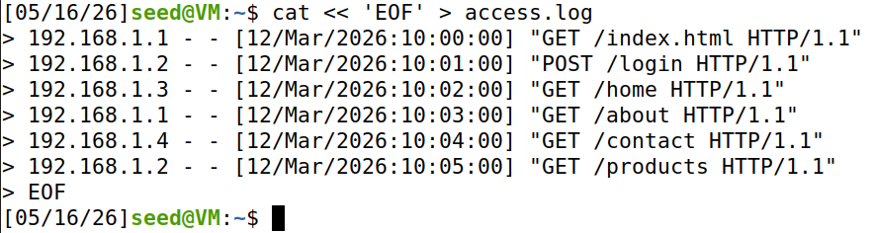
Part A: Basic Command Line
- Print hello world.
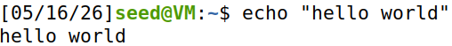
- Show the current working directory.
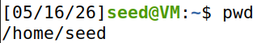
- List files and directories, one per line.
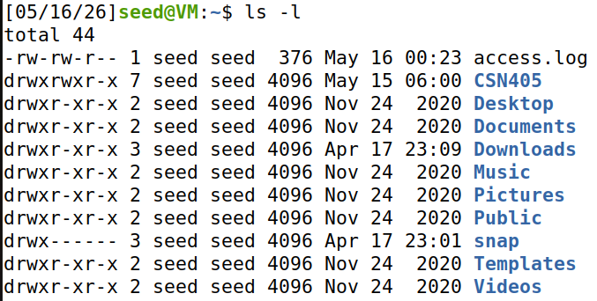
- Create an empty file named CSN405_file.txt
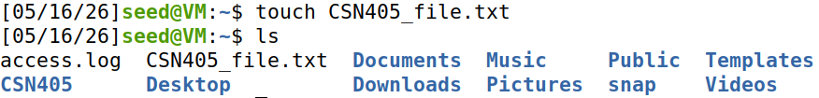
- Create the directory tmp/files.
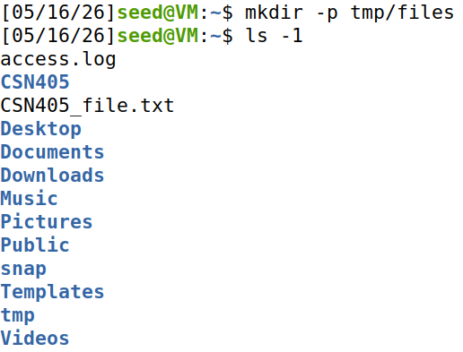
- Copy CSN405_file.txt into tmp/files.
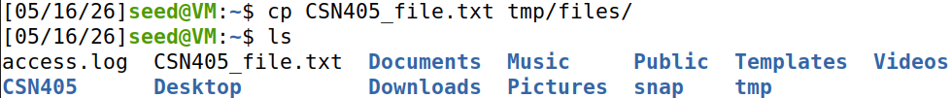
- Move CSN405_file.txt into tmp/files.
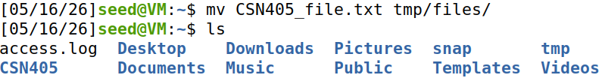
- List files at the current working directory
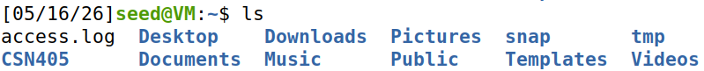
- Create a symbolic link to tmp/files/ CSN405_file.txt
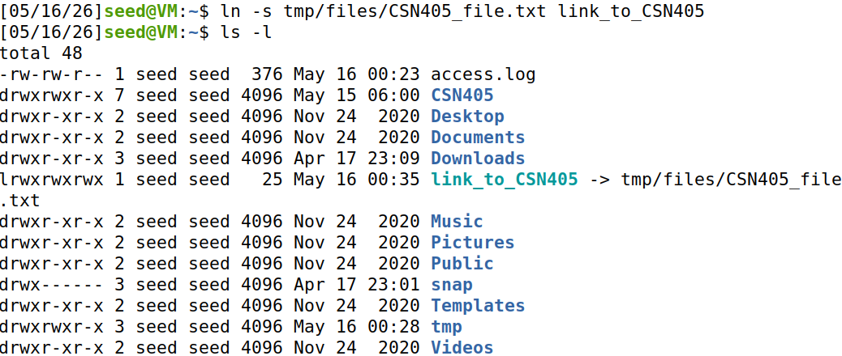
Explain what is symbolic link, what is the difference between symbolic link and hard link.
- A Symbolic Link (also known as a Soft Link or Symlink) is a special type of file in Linux that acts as a shortcut to another file or directory. Instead of containing actual data, it merely stores a text string representing the path to the target file. If the original file is deleted, the symbolic link breaks (becomes “dangling”) because the destination path no longer exists.
- Key Differences Between Symbolic Links and Hard Links
  - Target Connection: A symbolic link points strictly to the target's file path or name, whereas a hard link points directly to the target's Inode, which represents the actual physical data blocks on the disk.
  - Deletion Behavior: If the original file is deleted, a symbolic link breaks and becomes completely unusable. In contrast, a hard link remains fully functional, and the data stays accessible until all hard links pointing to that inode are removed.
  - File System Boundaries: Symbolic links can easily reference files across different partitions or hard drives (cross-filesystem). Hard links are strictly limited and must reside on the same partition as the original file.
  - Directory Restrictions: Symbolic links can be used to link directories, while Linux strictly prohibits hard links on directories to prevent dangerous system loops.
  - Storage and Creation: A symbolic link requires minimal storage since it only saves a path string, and it is created using ln -s. A hard link shares the exact same inode and size as the original file and is created using the base ln command.
Part B: Working with Text Files
- Display the full content of access.log.
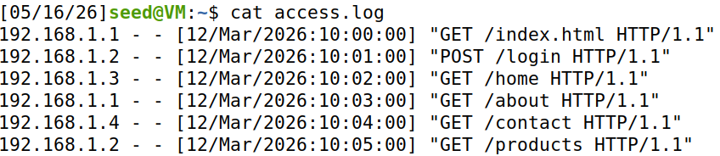
- Display the last 5 lines of access.log.
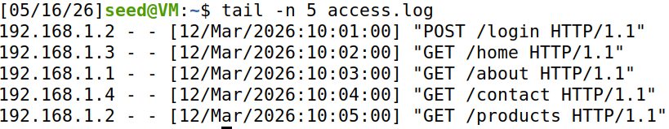
- Sort the content of access.log and print the result
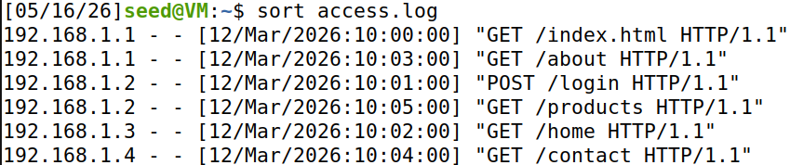

Part C: Searching and Counting
- Print all lines in access.log that contain GET.
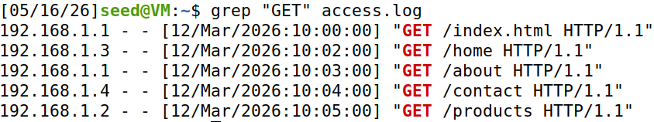
- Count how many lines in access.log contain GET.
- Extract all IP addresses from access.log.
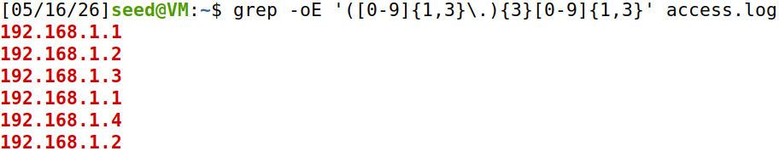
- Count the number of regular files in the current directory.
Part D: Bash Script
- Write a Bash script that prints numbers from 1 to 50 on one line, separated by spaces.
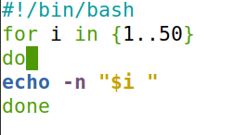
- Write a script to calculate the sum of two numbers entered by a user. (two ways)
Way 1:
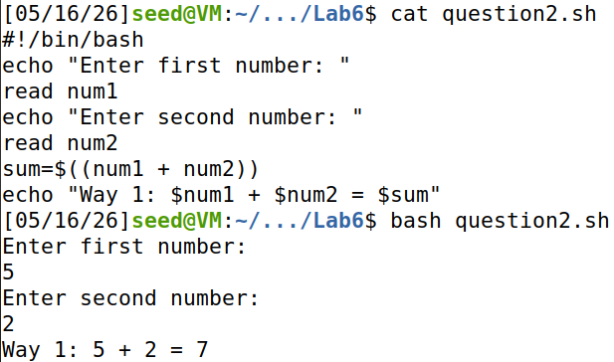
Way 2:
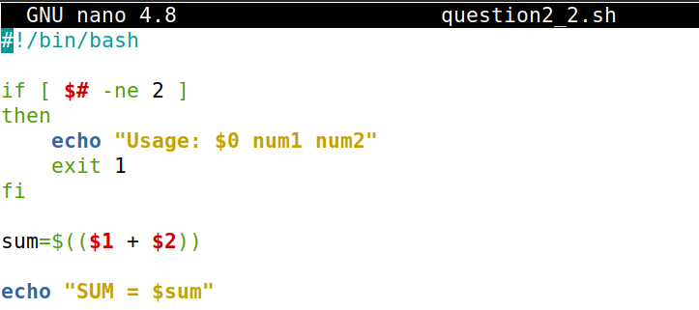
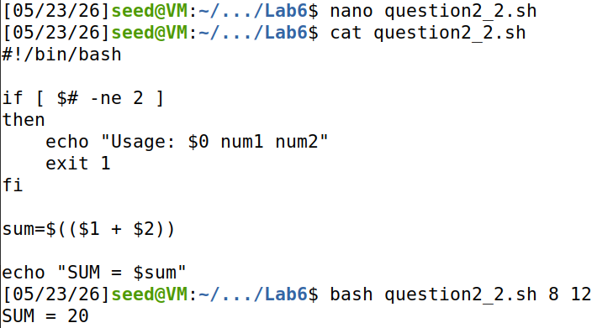
- Write a script that takes a number n as input and then prints the sum of its digits from 1 to n.
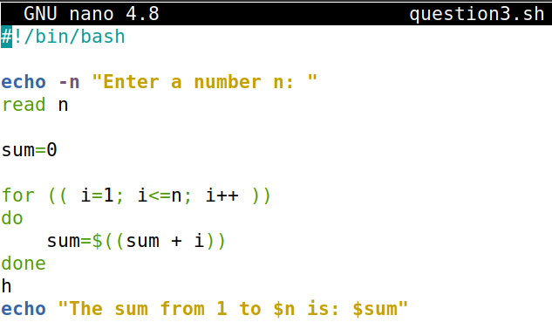
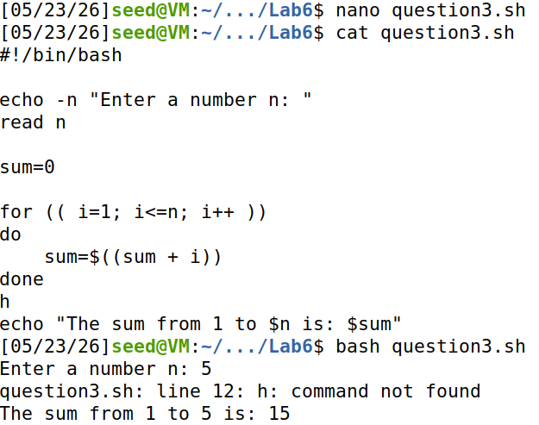
- Write a script to input the scores of 3 subjects, calculate the average, and then rank them as follows:
>= 8: Excellent
>= 6: Good
>= 5: Average
< 5: Poor
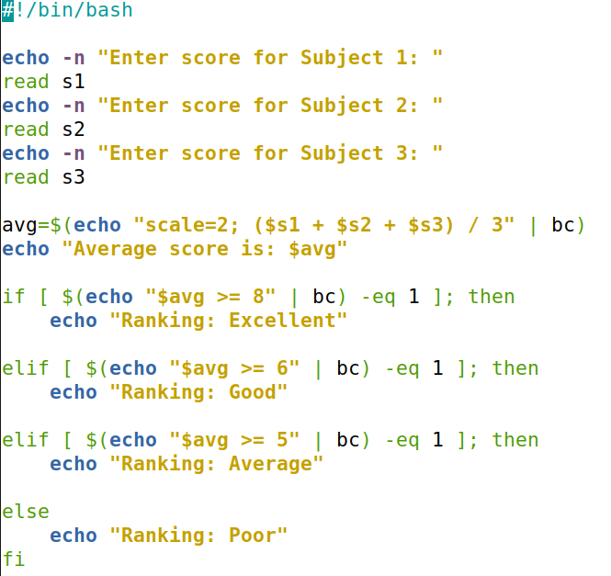
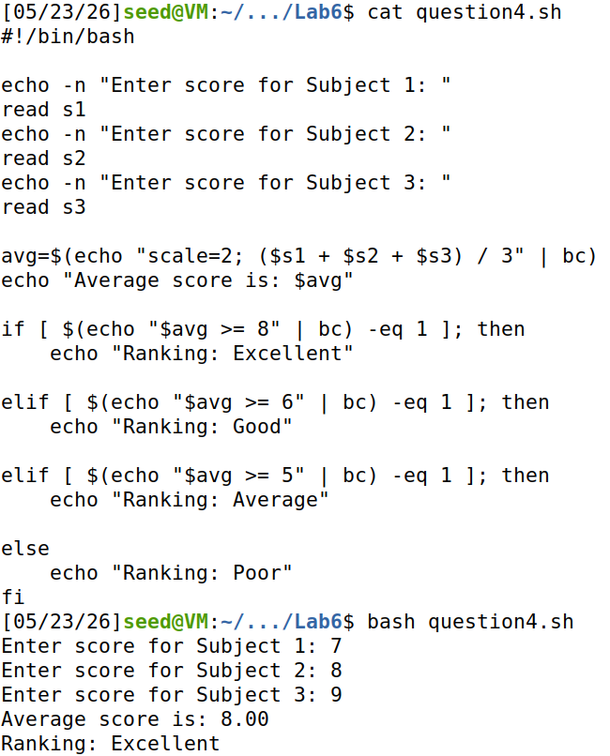
- Write a script that takes multiple numbers from command-line parameters and finds: the largest number, smallest number and sum
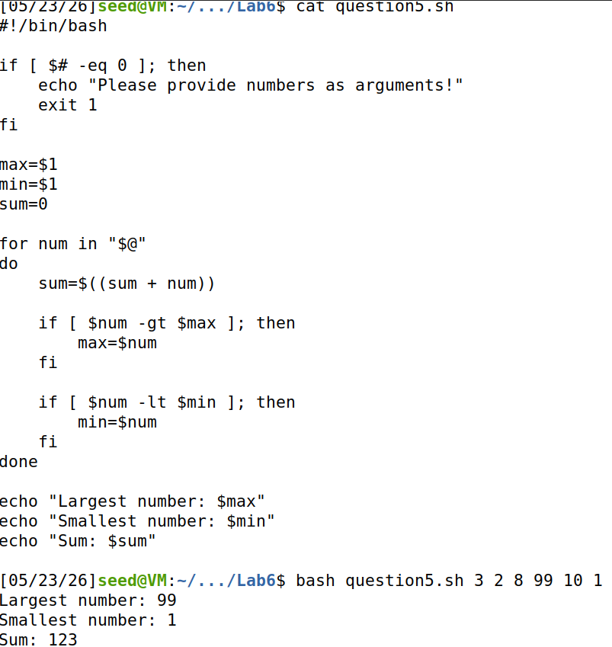
- Write a script to read numbers from the file numbers.txt (self-make) and calculate how many the prime number of the file. (Ex: NO. prime number: 1)
numbers.txt
3
4
6
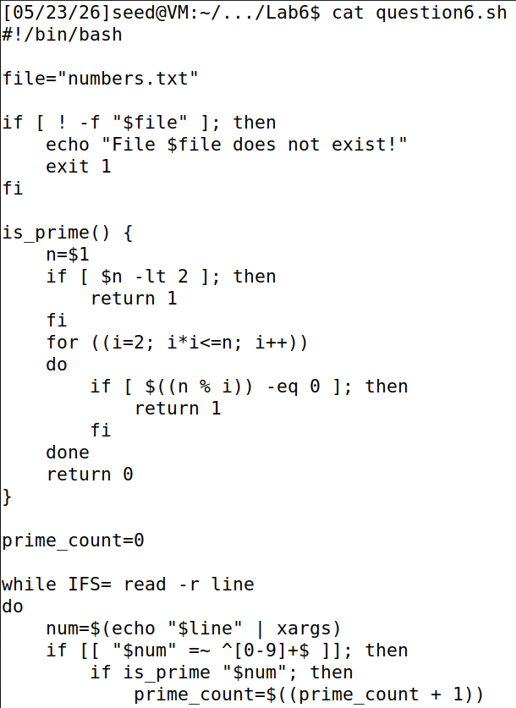
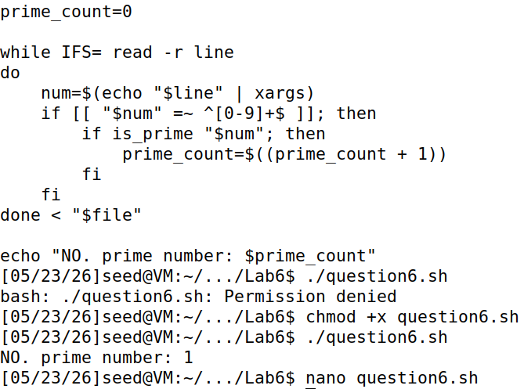
- Write a script to read a file containing multiple numbers, ignore invalid rows, and only sum rows that are integers.
Ex:
Input | Output
10  abc  7  hello  3 | Sum = 20
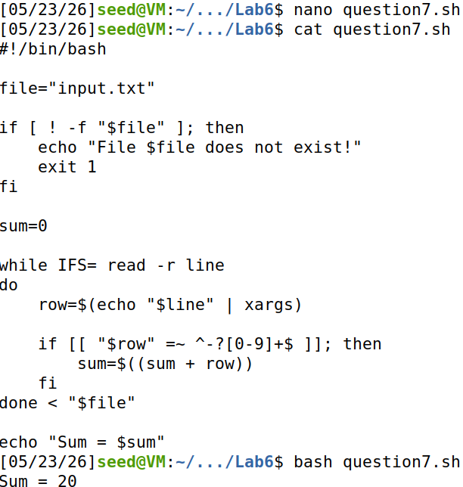
- Write a script for part C
